**DGA Consulting Services for Alarm Management in OT Systems**

**Importance of Alarm Management**

Alarms are a key element of any control system as they are essential in directing an Operator’s attention to those network conditions requiring timely assessment and action. The subsequent application of rapid corrective action from the operator could prevent a major incident, or damage to equipment, with associated potential safety, reputation and financial impact to the business.

The correct use of alarms should ensure that only important events are always highlighted to Operators who know, or can review, the appropriate action to take under different operating conditions. This requires systems and processes to be maintained to ensure alarms are presented at a rate that an operator can effectively handle and that are relevant, clear and easy to understand.

In a recent assignment DGA Consulting has been working with a network operator to define the application of industry best practice to the use of alarms by applying the ANSI/ISA standard for the management of alarms.

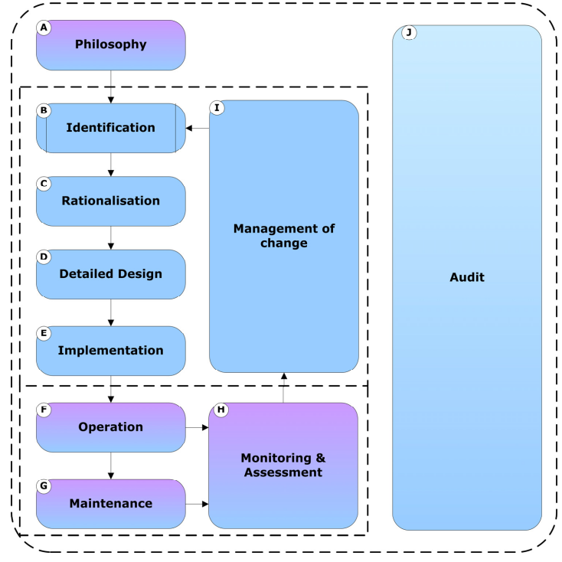**Alarm Management Lifecycle**

The ANSI/ISA-18.2-2016 Standard addresses the development, design, installation and management of alarm systems in process industries. It documents an Alarm Management Lifecycle which covers system specification, design, implementation, operation, monitoring and management of changes from initial conception to decommissioning (see Figure 1).

The lifecycle can be applied for new alarms and existing systems, and typically commences with the important step of creation of the alarm philosophy.

Figure 1 Alarm Management Lifecycle in ANSI Standard

**Alarm Management Philosophy**

The ‘Alarm Philosophy’ document serves as the framework to establish the criteria, definitions, principles, and responsibilities for all of the alarm management lifecycle stages. It specifies the methods for alarm identification, rationalisation, monitoring, management of change and auditing.

The Alarm Philosophy document facilitates four key principles for good practice in alarm management:

* Consistency across the entire alarm system (configuration, management, presentation and use),
* Consistency with risk management goals and objectives,
* Agreement with good engineering practices; and
* The design and management of an alarm system that supports an effective Operator response.

**Contents of the Alarm Philosophy.**

The Alarm Philosophy document acts as a guideline to facilitate the design of the alarm subsystem within both the control centre SCADA, EMS, DMS systems and substation Management Systems. Example key areas that need to be included in the alarm management philosophy are shown in the table below.

|  |  |
| --- | --- |
| **Areas** | **Scope** |
| Definitions and References | Confirm what constitutes an alarm and should be covered by the philosophy and details key documents that should be maintained as part of the lifecycle |
| Roles and Responsibilities | Outlines responsibilities for approving and managing alarms including the roles of the key alarm management committees |
| Design Principles and Design Guidance | General design principles for alarms and identification methods and application of alarm states with guidance on the information alarms should provide to operators |
| Alarm Setpoint Determination | Outlines how the setpoint values for alarms should be derived including the need to ensure adequate time for the operator to respond. |
| Prioritisation Method | Details how priorities are established for alarms including risk assessments of the implications of alarmed events and the criticality of different alarms |
| Rationalisation and Maintenance | Outlines process for which existing and new alarms are review, justified and documented in the Master Database in line with the philosophy |
| Response Procedures | Details the response procedures required for each alarm type including during abnormal conditions. These procedures/guidance notes will be stored on a separate system |
| Training | Training is required for control room operators and those using substation HMIs to ensure operators know the correct procedures for responding to an alarm |
| Shelving and Suppression | Shelving is the temporary disablement of an alarm whereas suppression is usually an automatic function designed to reduce alarm flooding. Clear rules are needed to ensure the safe management of shelved/suppressed alarms |
| Management of Change | Management of change is a separate stage of the alarm lifecycle covering requirements and approval for addition of new alarms and modification to existing alarm properties |

**How DGA Can Help Network Businesses?**

DGA Consulting can work closely with network businesses to understand their current operating practices, philosophy and issues faced in the management of alarms. Our role can include creating/revising the alarm management philosophy and making recommendations on how current practice can be modified to align with the ANSI Standard. In addition, DGA Consulting can develop detailed alarm management procedures if they do not already exist.

**Benefits of Working with DGA Consulting**

* Practical understanding of how alarms are applied in the control room;
* Detailed understanding of best practice on the management of alarms;
* Comprehensive knowledge of OT systems used to generate alarms; and
* Consultants experienced in collaborative reviews of OT policies and maturity models